Microservices:

If package everything in one ear: long release cycle, big budget, big delays, many unused features, expensive to change, difficult to scale, slow payback of return on investment, drag on business model innovation, source of conflict b/w IT and business, difficult to understand monolithic codebase

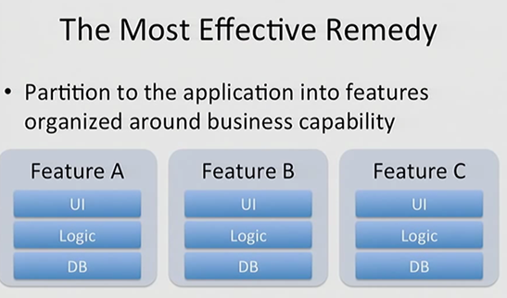

Break big app into small microservices, each with own backend and business logic. Could be just backend data-services. No need of UI. Deliver each service as separate microservice executable.

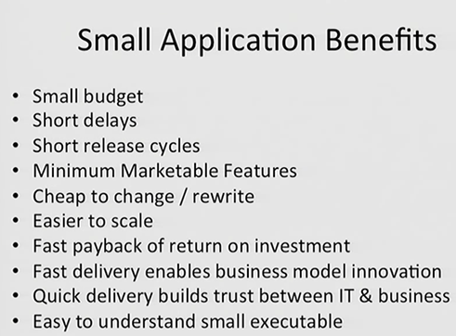

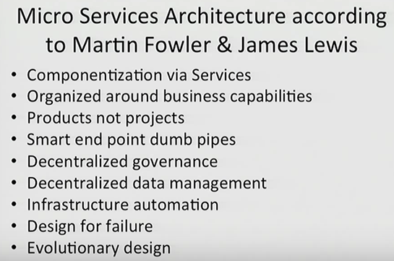

Business functionality sliced into layers for eg: ebay : diff service for handling customer profiles, other for auction, another for payment.

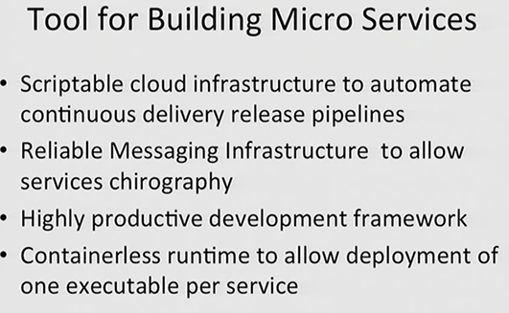

Light-weight development framework.

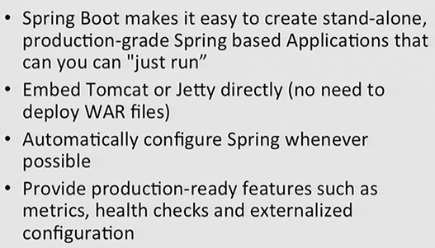

**Spring-boot-starter-actuator:**

Some pre-defined endpoints like localhost:8080/beans: spring beans which are registered.

/metrics: memory the app has, how many times endpoints were executed

/dump:

**Spring-boot-starter-remote-shell:**

Using default password for shell access: 252b1332-cbdb-45dd-8427-fd644a4500b3

Username: user

**Flywaydb dependency**

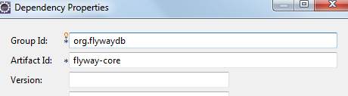

Automatically create tables for us. Looks for a .sql file under db/migration/ and each file executes as 1 transaction.

**Command Line Runner**

Things we wish to do as soon as spring boot application loads up, we can do using the command line runner like initializing the data. CommandLineRunner is a simple interface with the run method taking in String[] arguments.

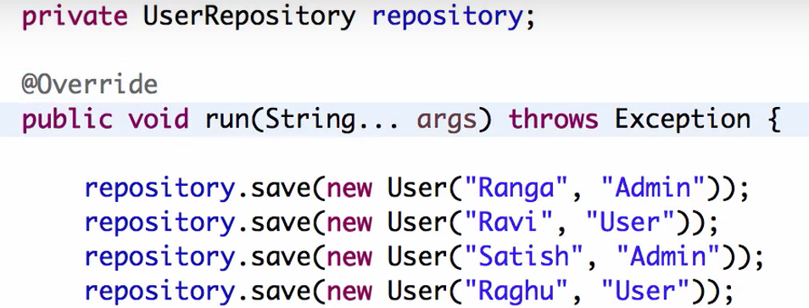

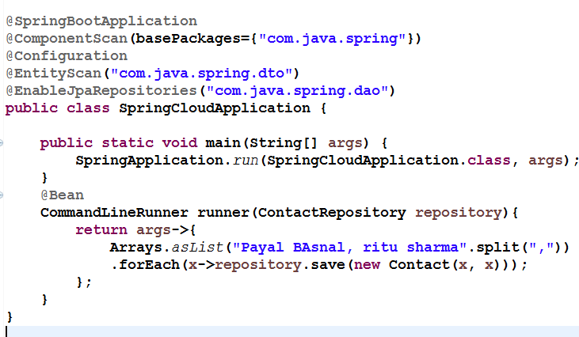

**Distributed tracing and Zipkin:**

**Monolithic applications:**

They have scaling problems. 1 single application doing everything. Large app. Difficult to understand, manage, maintain, test, deploy. Difficult to adapt to new technology.

**Microservices**

1. Small: Do 1 thing well. 1 responsibility,
2. 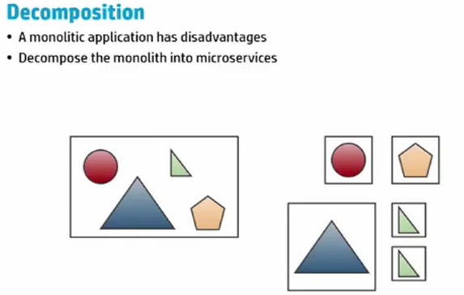

Once decomposed, one block can be deployed multiple times into production, is reusable.

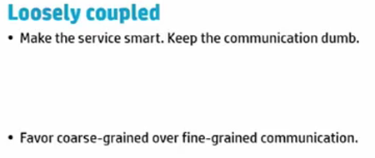

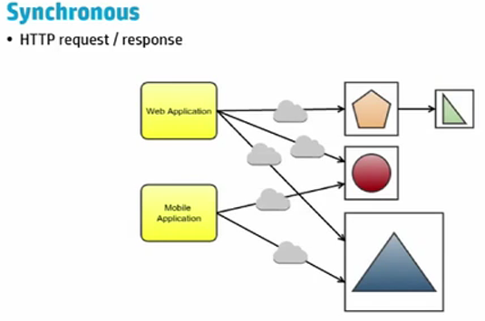

Synchronous: Not good idea for large application with diff services. Gateway can be used to make it faster.

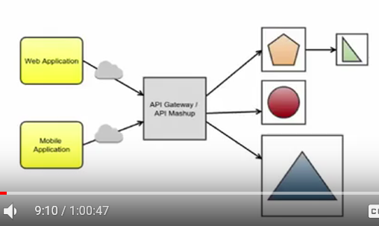

Or api meshup like a composite service which can call other services internally. Orchestrating services.

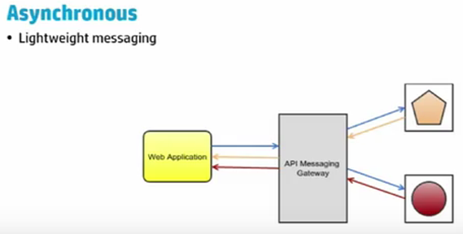

Single point of failure if service fails in synchronous app.

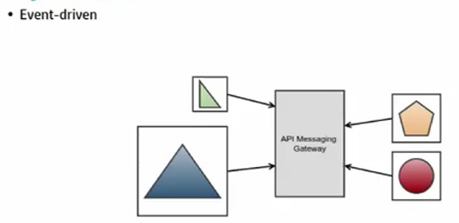

Microservices starts talking to each other. Publish subscribe.

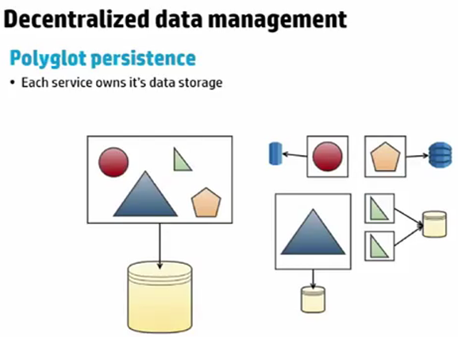

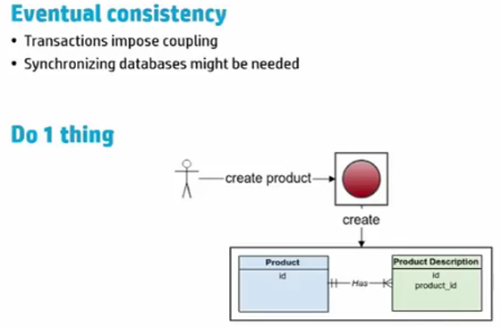

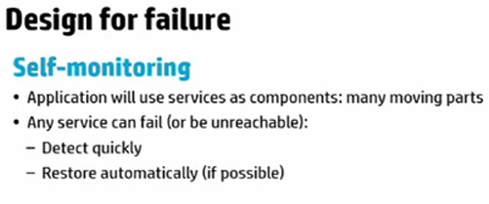

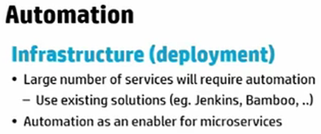

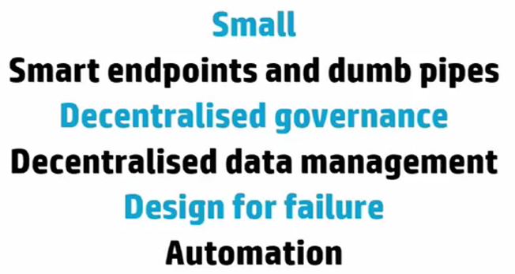

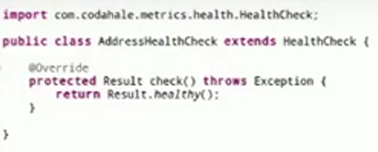

Default drop wizard comes with a jetty application, not with tomcat

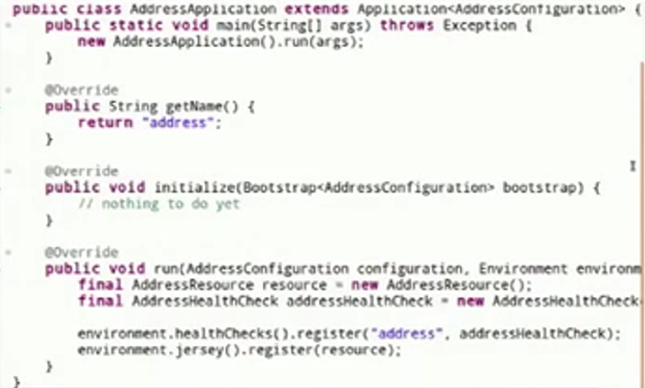

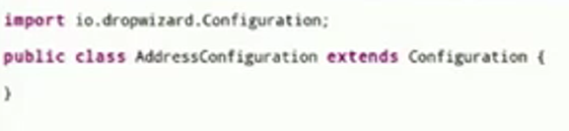

Drop wizards need configuration to connect to other web-service/ db

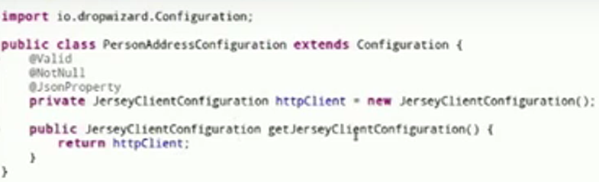

Here it uses jersey client to call other web services.

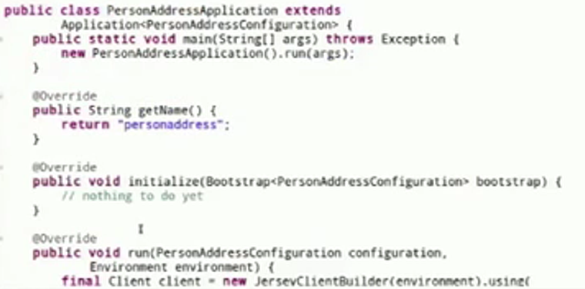

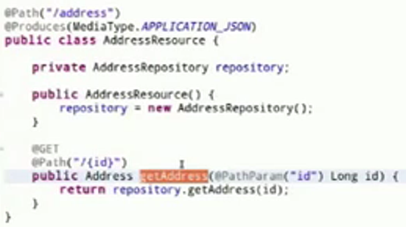

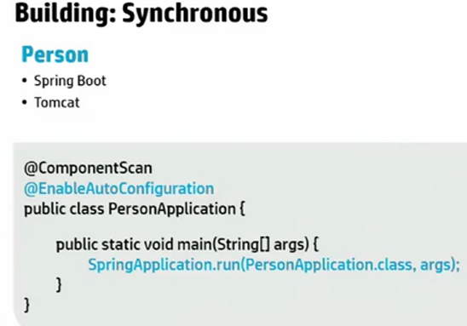

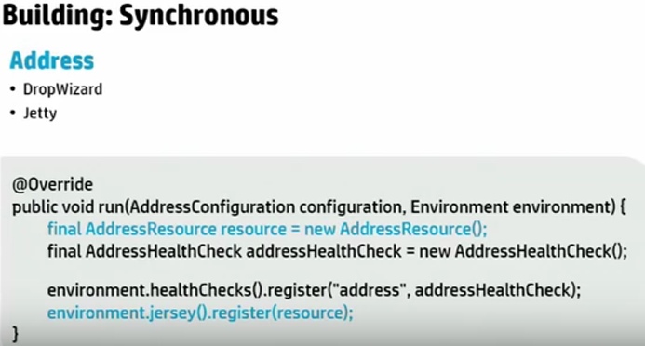

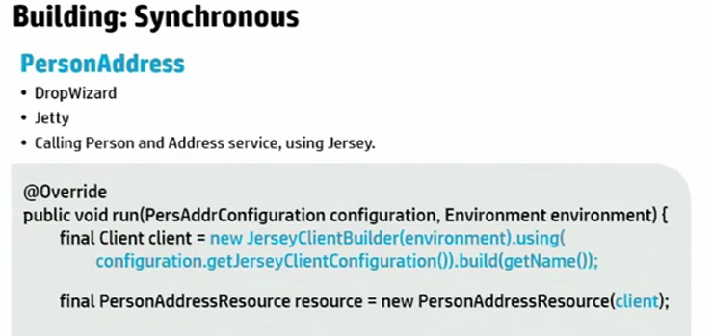

Jersey client calling 2 other microservices.

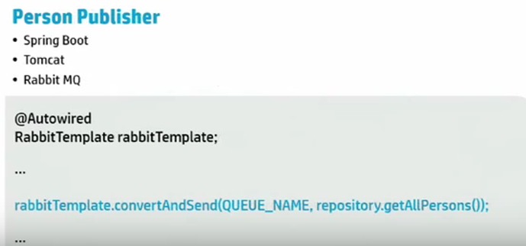

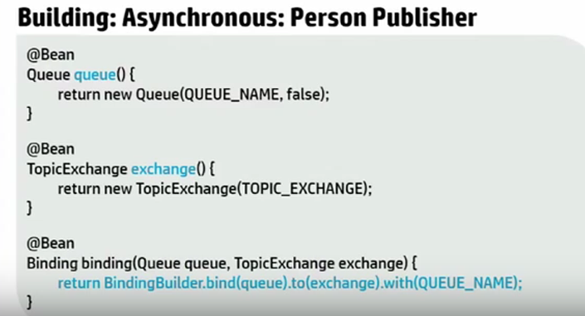

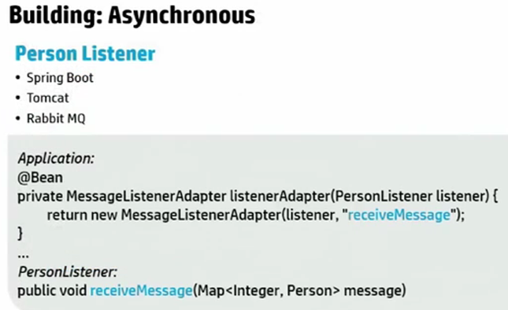

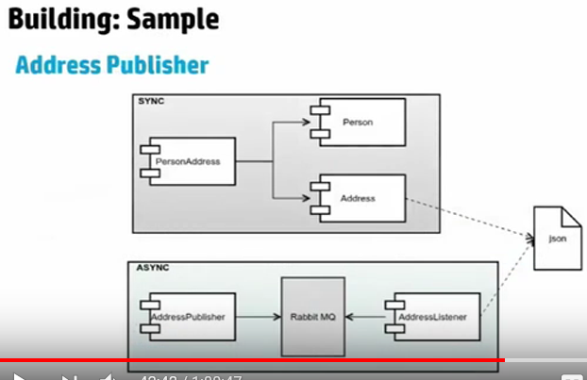

Who invoked the service, tracked using correlationid

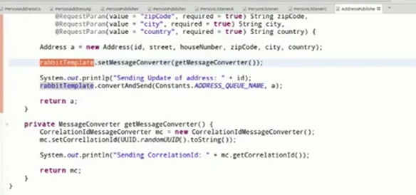

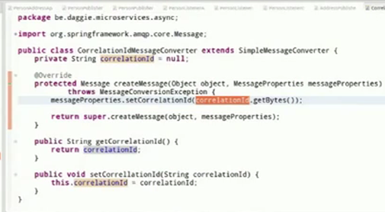

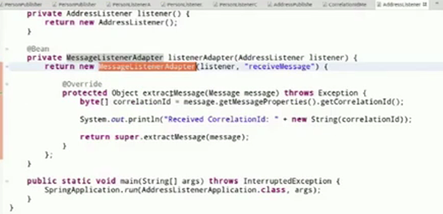

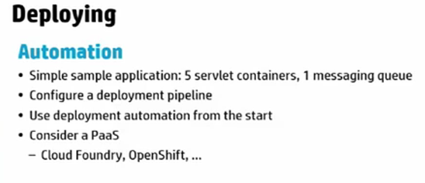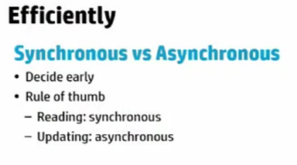

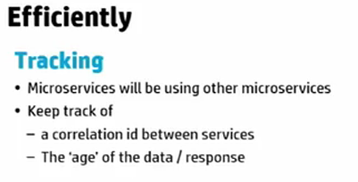

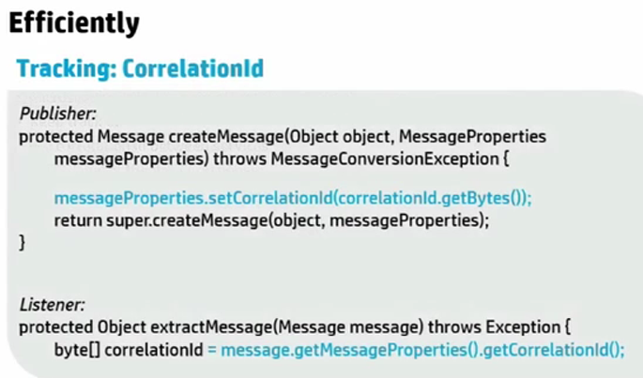

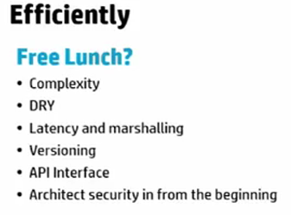

Discovery service: Eureka: Registry service: where they are located

Spring cloud: java –jar : can be executed from anywhere, whether local machine/ cloud foundry/ aws

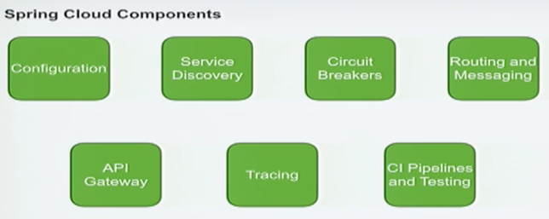

Circuit breakers: Prevent failures

Tracing: visualize/ trace request.

CI pipelines:

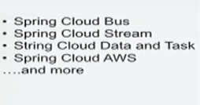

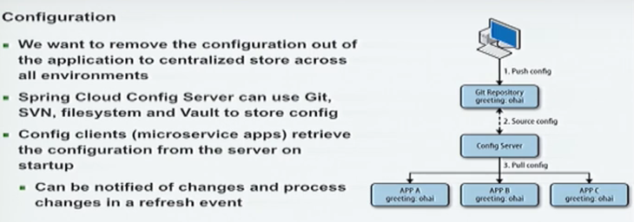

To change the logging level, do not have to go to all the applications to do that.

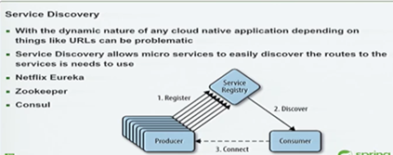

Instances may change. Where instances are

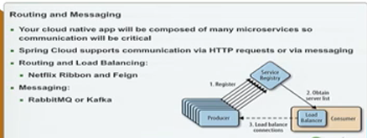

Route specific messages to particular service. Built in Client side Load balancer which will route the request accordingly for us.

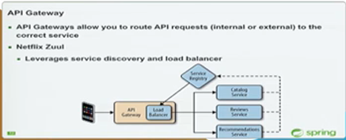

Can shield client requests from services behind the gateway. Services can be scaled.

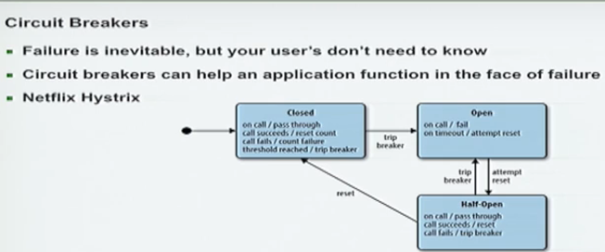

If one service having problem, request is prevented from hitting that service and served with cached data. Helps preventing cascading failures.

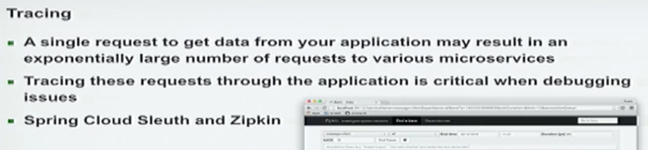

ElasticSearch also for logging data

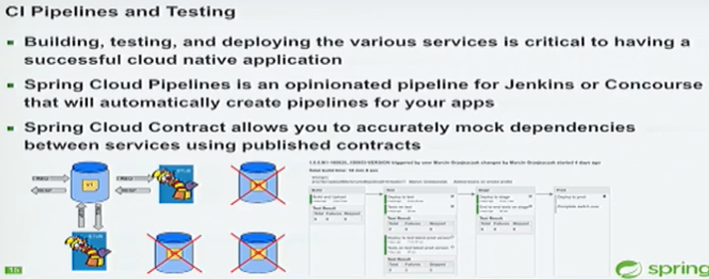



Spring cloud will startup configserver, eureka server and zipkin

Configserver.yml: specify where is config file

Application.yml: will apply these settings to all servers

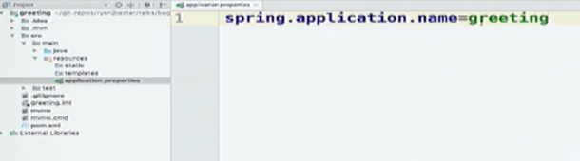

Configserver uses it to find the name of the config file for that service. It matches greeting.yml filename. Also this is the name with which my application registers itself in Eureka. I am greeting service, located at this url.

@EnableDiscoveryClient: Registers the app with Eureka.

We need to provide sampler to spring cloud suit to send log information off the zipkin

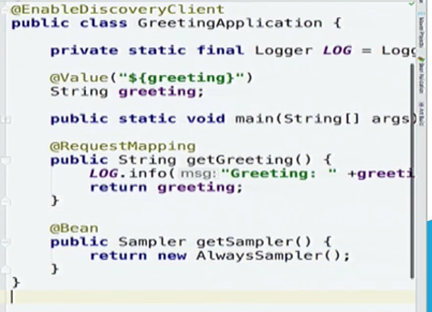

AlwaysSampler sends everything to zipkin

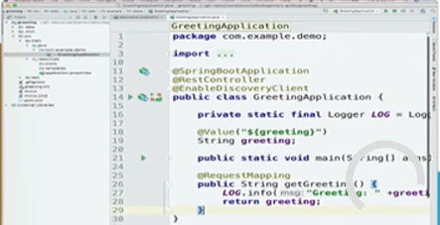

Service dependencies:

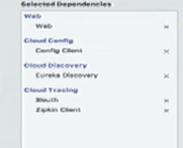

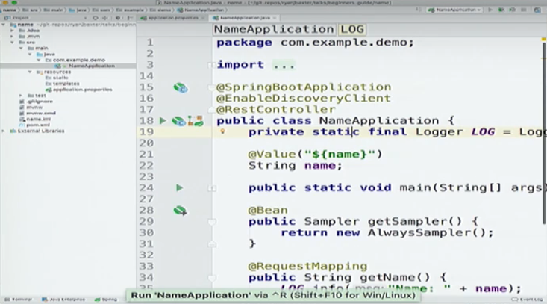

ConfigServer.yml: config server configurations

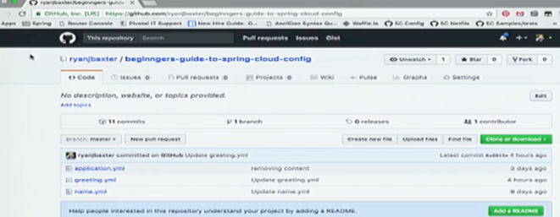

Repository

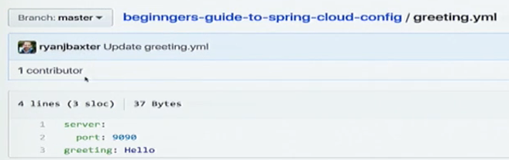

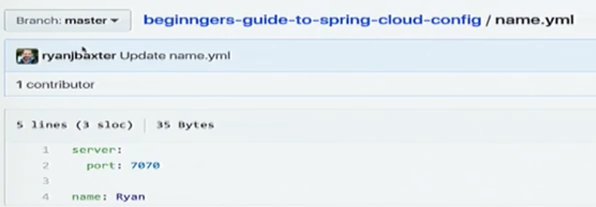

**Service which combines these 2 services**

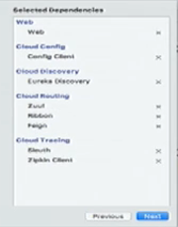

Added ribbon, zuul, feign

To make request to the greeting service, using RestTemplate:

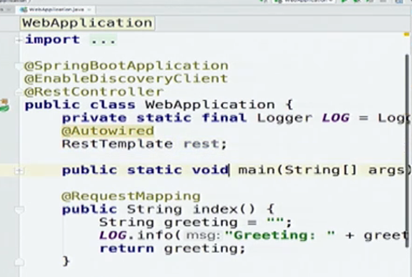

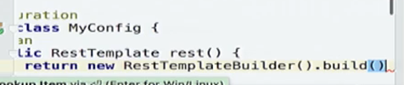

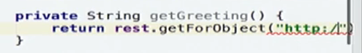

url where greeting service is located

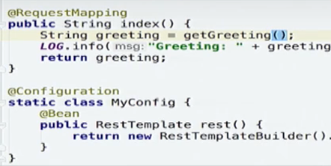

Now instead of hardcoding url, will use service discovery to find the url

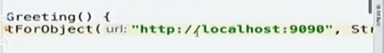

Aslo don’t know how many instances running, may have moved down from 2 to 1

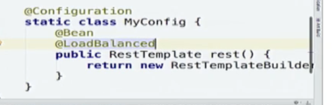

So just add @LoadBalanced annotation.

Instead of specifying url, change it to the name of the service

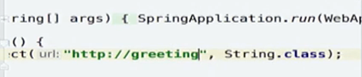

Also adding sampler:

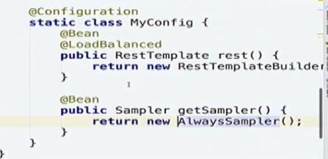

We can use LoadBalancer to get other service too, but using Feign now. With Feign, can use webmvc mapping annotations to do that.

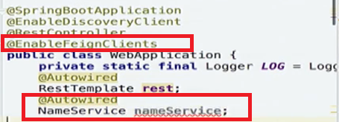

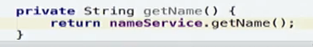

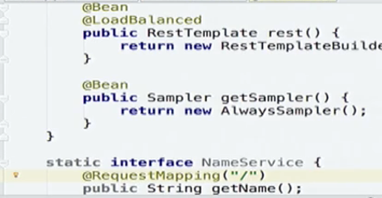

Annotate this interface with @FeignClient with the name of the service you want to inject

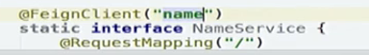

EnableFeognClients in application. Also Enable Zuul on this along with Feign

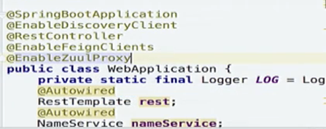

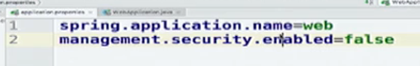

Zuul proxy added some routes to teh application

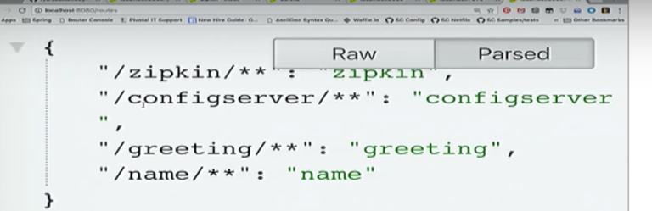

So can call those services also from this application.

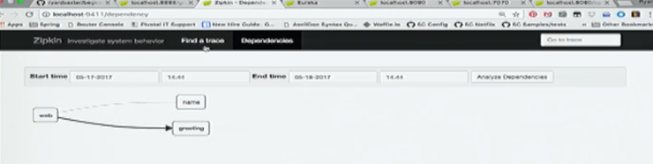

Tracing tool: zipkin

/dependency

/metrics:

/health

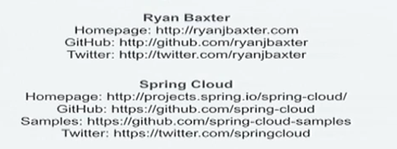

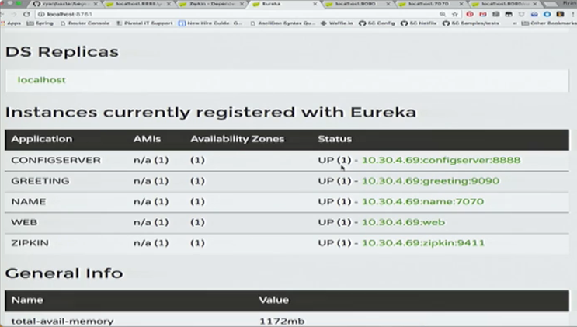

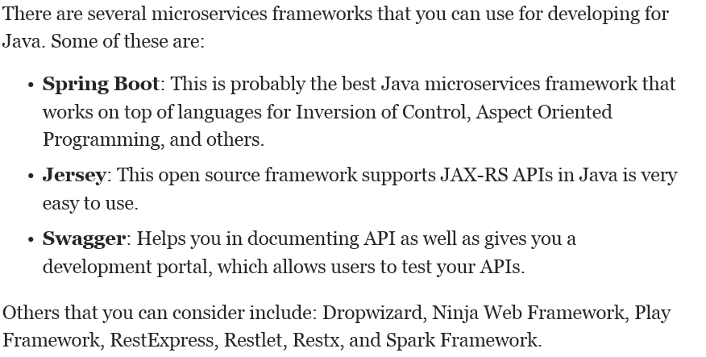

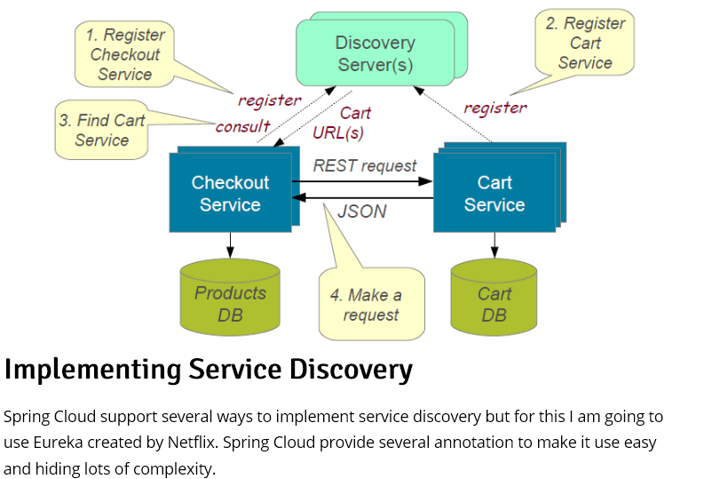

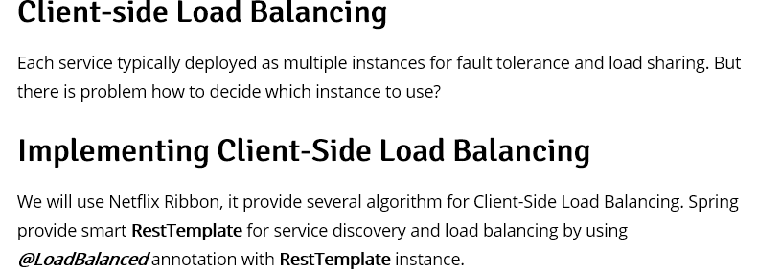

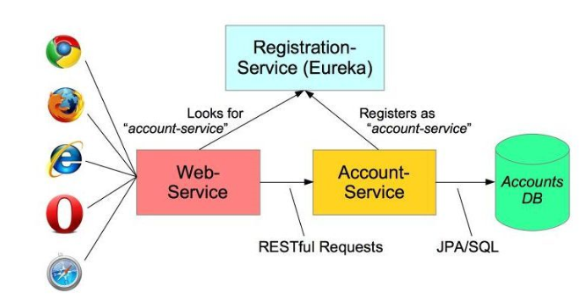

we are using Netflix Ribbon as a client-side load balancer. That enables us to achieve fault tolerance and increase the reliability and availability through redundancy. We are using Netflix Foreign for writing declarative REST client, and integrating Ribbon and Eureka to provide a load balance HTTP client.

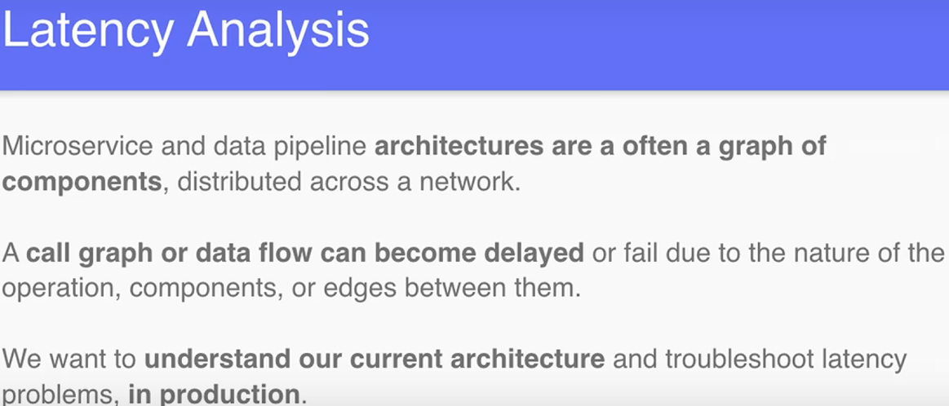

if you apply the Microservice Architecture pattern you must then apply numerous successor patterns including service discovery patterns and the Circuit Breaker pattern. first decision you must make is whether to use a [Monolithic architecture pattern](http://microservices.io/patterns/monolithic.html) or the [Microservice architecture pattern](http://microservices.io/patterns/microservices.html). If you pick the Microservice architecture pattern you must choose numerous other patterns to deal with the consequences of your decision.

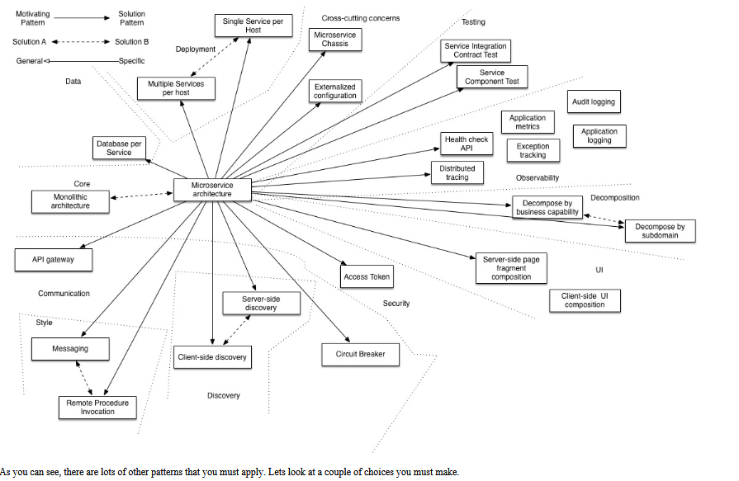

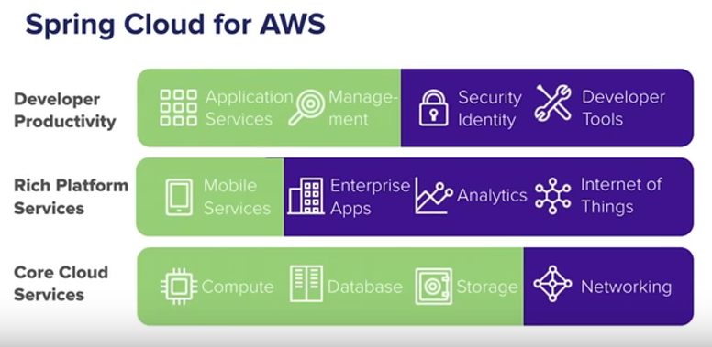

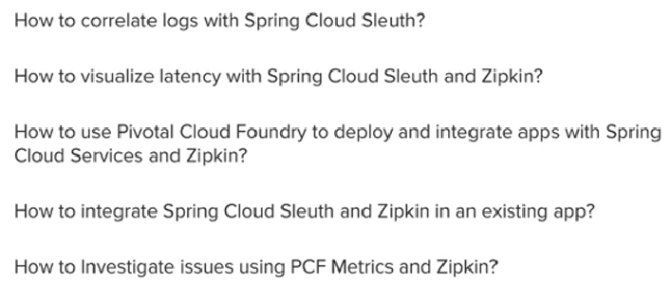

1. Which server instance was exception thrown, if many services running on many instances.
2. So through span (time for each service), trace(set of spans), logs() , tags(key value pair) try to find out the same
3. 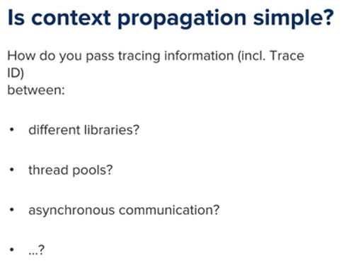
4. 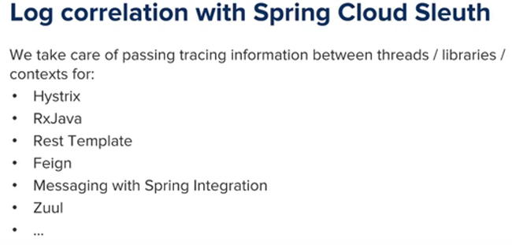
5. 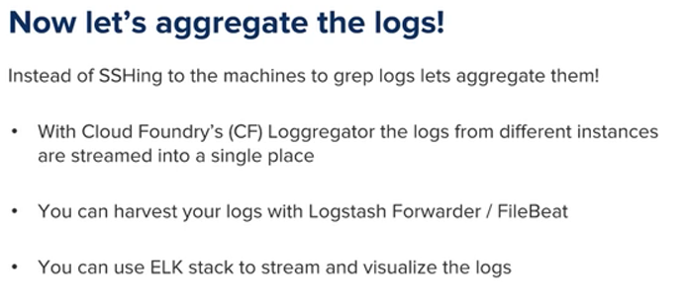
6. 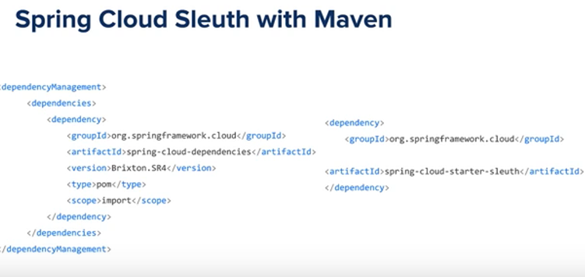

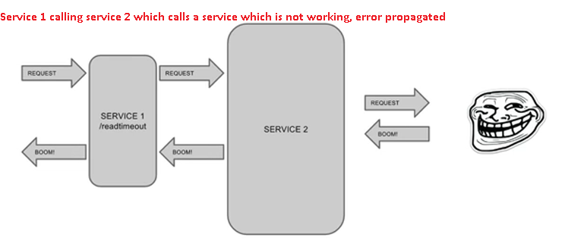

**ELK Stack (Elasticsearch logstash kibana)**

**Log analysis:**

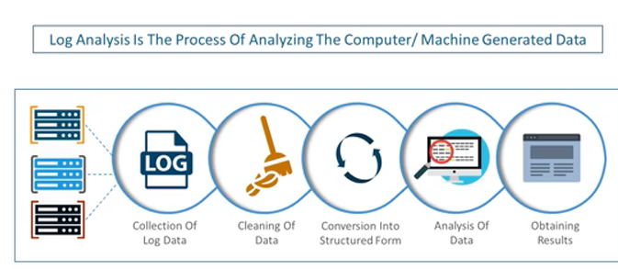

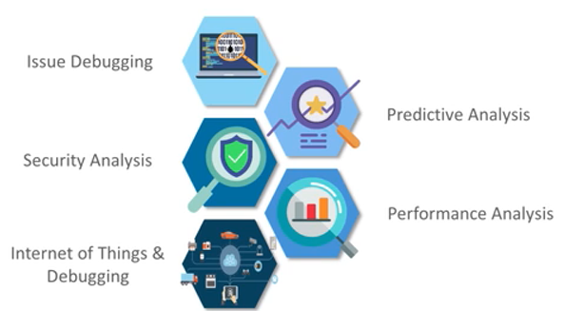

Name of the stocks held by this client (Stock Manager): clients + stocks

Client name : stock prices and the name of the stock

**P**

Oracle

**Feign/Ribbon**

Api Gateway

8761 /yahooservice/zuul/routes

Angular

Add a stock for a client

Stock Name: Appl

Enter client name: Payal

**Configuration Server**: remove configuration out of the application to a centralized store across all environments. Can use git, svn, filesystem and vault to store config. Config clients / services retrieves configurations from the server on startup. Can be notified of the changes and process changes in a refresh event. Spring Cloud Config provides server and client-side support for externalized configuration in a distributed system. It is a microservice for creating properties. Can externalize all properties to a distributed environment and in client can use @Value(${user.name})

Spring cloud by default looks for properties in config folder inside the resource folder.

By default cloud looks for git repository.

Can change it by spring.profiles.active=native //for file system

**For server:**

In pom.xml:

<dependency>

<groupId>org.springframework.cloud</groupId>

<artifactId>spring-cloud-config-server</artifactId>

</dependency>

In main class: @EnableConfigServer

To run your own server use the spring-cloud-config-server dependency and @EnableConfigServer. If you set spring.config.name=configserver the app will run on port 8888 and serve data from a sample repository. You need a spring.cloud.config.server.git.uri to locate the configuration data for your own needs (by default it is the location of a git repository, and can be a local file:.. URL).

As long as Spring Boot Actuator and Spring Config Client are on the classpath any Spring Boot application will try to contact a config server on http://localhost:8888 (the default value of spring.cloud.config.uri):

To make config server as a client for itself, it can also look in it:

Spring.cloud.config:

Server:

Bootstrap: true

encrypt.key: “symmetricKeyValue_default”

spring.application.name: configServerExample

//to search native environment-repository (file system) instead of git

spring.profiles.include: native

spring.cloud.config.server.native.searchLocations: file://${user.parent.dir}/sample-config-repo/•

**For clients:**

Spring Boot application that depends on spring-cloud-config-client (e.g. see the test cases for the config-client, or the sample app). The most convenient way to add the dependency is via a Spring Boot starter org.springframework.cloud:spring-cloud-starter-config.

<dependency>

<groupId>org.springframework.cloud</groupId>

<artifactId>spring-cloud-starter-config</artifactId>

<version>1.4.0.RELEASE</version>

</dependency>

In yml/ property file:

spring.cloud.config.uri=http://localhost:8888

1. Key/value configuration
2. Encrypt/decrypt configuration: download Java cryptography extension as per your jdk

<http://www.oracle.com/technetwork/java/javase/downloads/jce8-download-2133166.html>

(for jdk8)

Replace jars in C:\Program Files\Java\jdk1.8.0_25\jre\lib\security folder with the jars downloaded from this zip.

By default spring gives /encrypt and /decrypt endpoint

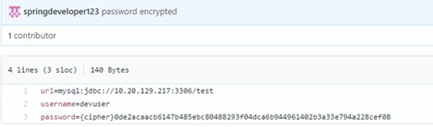

Can disable default decrypt happening at server:

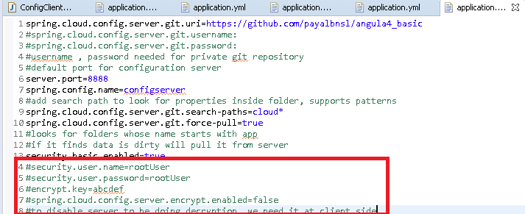

At client side need to give encrypt key again to be able to decrypt the username, password.

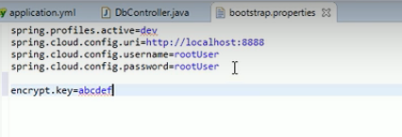

management.security.enabled=false will disable the spring security on the management endpoints like /env, /refresh etc. This is for development settings, in production security should be enabled.

1. @refreshscope for allowing properties to refresh: Bean data is cached , to tell it explicitly to refresh the content
2. Backed by many storage options like git
3. extensible

**Securing config server:**

Spring-boot-starter-security as a dependency. Along with spring-cloud-config-server.

Spring will generate default password. Username: user

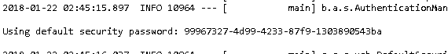

So clients now need to pass this password to be able to access the config server.

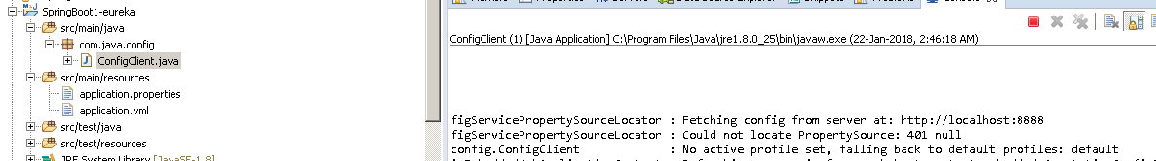

Instead of spring generating password and user as username , can mention own username password as:

On config server:

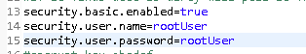

If you prefer to use Eureka to locate the Config Server, you can do that by setting spring.cloud.config.discovery.enabled=true (default "false"). The net result of that is that client apps all need a bootstrap.yml (or an environment variable) with the Eureka server address, e.g. in eureka.client.serviceUrl.defaultZone

The default service id is "CONFIGSERVER" but you can change that on the client with spring.cloud.config.discovery.serviceId (and on the server in the usual way for a service, e.g. by setting spring.application.name).

On client of config:

If you prefer to use DiscoveryClient to locate the Config Server, you can do that by setting spring.cloud.config.discovery.enabled=true (default "false"). The net result of that is that client apps all need a bootstrap.yml (or an environment variable) with the appropriate discovery configuration

**Config Client Fail Fast**

In some cases, it may be desirable to fail startup of a service if it cannot connect to the Config Server. If this is the desired behavior, set the bootstrap configuration property spring.cloud.config.failFast=true and the client will halt with an Exception.

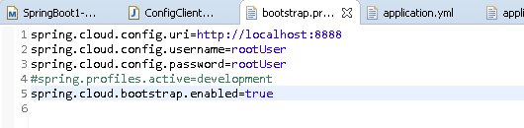

Populated by:

1. application.properties
2. application.yml : key1=count
3. bootsrap.yml: ke3=shark
4. parameters
5. system properties : key2=dragon
6. environment variables : key1=banana
7. command line arguments: key1=apple

precedence: config server -> command line -> system.properties -> system env -> application.yml -> bootstrap.yml

View/Fetch configuration:

[http://localhost:8080/config/{name-of-application}/{profile}/{label: tag/branch}](http://localhost:8080/config/%7bname-of-application%7d/%7bprofile%7d/%7blabel:%20tag/branch%7d)

Encrypt values:

curl localhost:8080/encrypt –d <encryptme>

Decrypt values:

curl localhost:8080/decrypt –d <encrypted text>

Refresh a client:

curl –X POST <http://localhost:8080/refresh>

Bean annotated with @**RefreshScope**. Need to add spring-starter-actuator as the dependency

Spring actuator by default adds security. Clients need to send post request at /refresh endpoint to get the changes. Can disable security by:

Management.security.enabled=false

@RestController

@RefershScope //will clear cache content and update the data

Public class GreetingController{

Public GreetingController(@Value(“${greeting.name}”)String name){

this.name= name;

}

}

@Component

@**ConfigurationProperties**(“greeter”)

Public class GreeterProperties{

Private String name;

Private List<String> from= new ArrayList<>();

}

Type Safety, Improved yml support. Automatically @RefreshScope enabled. Needs @EnableConfigurationProperties and adding as a bean.

Github.com/checketts/config-server-example

Profiles

Annotation Support:

1. @Value(“{myprop}”)
2. @ConfigurationProperties

To add spring security:

Spring-boot-starter-security as dependency.

In application.properties:

Security.user.name=payal

Security.user.password=password

**Example of config server using file system as a repository**

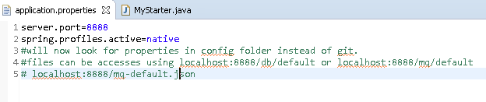

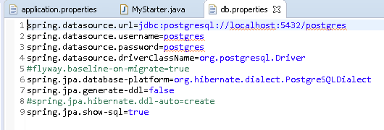

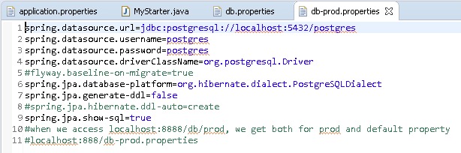

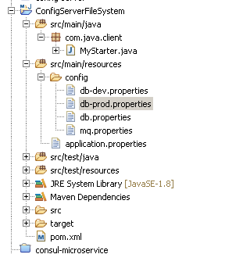

To retrieve from other locations:

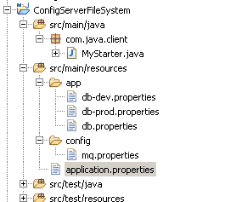

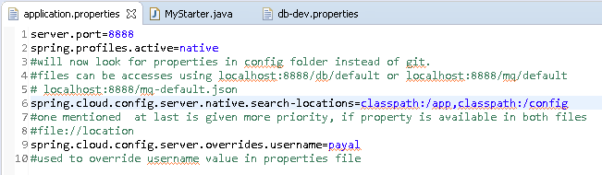



**Using Git repository:**

For private repository, need to provide username and password.

**service discovery**: know where services live, interact with each other. With the dynamic nature of cloud native app, depending on urls can be problematic. Service discovery allows microservices to easily discover the routes to services it needs to use. eg: Netflix eureka, zookeeper, consul

**circuit breakers**: protect applications in term of failure, isolate clients from these problems. Can help application function in face of failure. Netflix Hystrix

**routing and messging**: api request b/q microservices, sending messages. Spring cloud supports communication via http requests or via messaging. Routing and load balancing (round robbin or on basis of latency): Netflix ribbon, open feign. Messaging: rabbitmq, kafka

api gateway: pulbic api, front-end client making call to api. Route api requests to correct service. **Netflix zuul**. Leverages service discovery and load balancing. Spring cloud gateway.

**tracing**: latency measurement of each component in a distributed transaction where multiple microservices are invoked to serve a single business usecase. Spring cloud sleuth + zipkin

**ci pipelines and testing**: Spring cloud pipeline is an opinionated pipeline for Jenkins or concourse that will automatically create pipelines for our apps. Spring cloud contract allows us to accurately mock dependencies between services using published contracts.

spring cloud bus, stream, data and task, aws

<http://bit.ly/beginners1p>

Many of those features are covered by [Spring Boot](http://projects.spring.io/spring-boot), which we build on in Spring Cloud. Some more are delivered by Spring Cloud as two libraries: Spring Cloud Context and Spring Cloud Commons. Spring Cloud Context provides utilities and special services for the ApplicationContext of a Spring Cloud application (bootstrap context, encryption, refresh scope and environment endpoints). Spring Cloud Commons is a set of abstractions and common classes used in different Spring Cloud implementations (eg. Spring Cloud Netflix vs. Spring Cloud Consul).

he bootstrap.yml (or .properties) location can be specified usingspring.cloud.bootstrap.name(default "bootstrap") orspring.cloud.bootstrap.location(default empty), e.g. in System properties.

If we change the value of any of the key (value of the property files attribute key for any environment) we don't even need to restart the Config Server and Config Client, Just send **HTTP POST** request to**http://localhost:8080/refresh** *the updated values will be reflected automatically.*

[**https://github.com/Netflix/Hystrix/wiki/Configuration**](https://github.com/Netflix/Hystrix/wiki/Configuration)

Hystrix is designed to do the following:

* Give protection from and control over latency and failure from dependencies accessed (typically over the network) via third-party client libraries.
* Stop cascading failures in a complex distributed system.
* Fail fast and rapidly recover.
* Fallback and gracefully degrade when possible.
* Enable near real-time monitoring, alerting, and operational control.

Hystrix works by:

* Preventing any single dependency from using up all container (such as Tomcat) user threads.
* Shedding load and failing fast instead of queueing.
* Providing fallbacks wherever feasible to protect users from failure.
* Using isolation techniques (such as bulkhead, swimlane, and circuit breaker patterns) to limit the impact of any one dependency.
* Optimizing for time-to-discovery through near real-time metrics, monitoring, and alerting
* Optimizing for time-to-recovery by means of low latency propagation of configuration changes and support for dynamic property changes in most aspects of Hystrix, which allows you to make real-time operational modifications with low latency feedback loops.
* Protecting against failures in the entire dependency client execution, not just in the network traffic.

Hystrix does this by:

* Wrapping all calls to external systems (or “dependencies”) in a HystrixCommand or HystrixObservableCommand object which typically executes within a separate thread (this is an example of the [command pattern](http://en.wikipedia.org/wiki/Command_pattern)).
* Timing-out calls that take longer than thresholds you define. There is a default, but for most dependencies you custom-set these timeouts by means of “properties” so that they are slightly higher than the measured 99.5th percentile performance for each dependency.
* Maintaining a small thread-pool (or semaphore) for each dependency; if it becomes full, requests destined for that dependency will be immediately rejected instead of queued up.
* Measuring successes, failures (exceptions thrown by client), timeouts, and thread rejections.
* Tripping a circuit-breaker to stop all requests to a particular service for a period of time, either manually or automatically if the error percentage for the service passes a threshold.
* Performing fallback logic when a request fails, is rejected, times-out, or short-circuits.
* Monitoring metrics and configuration changes in near real-time.

**Spring cloud aws:**

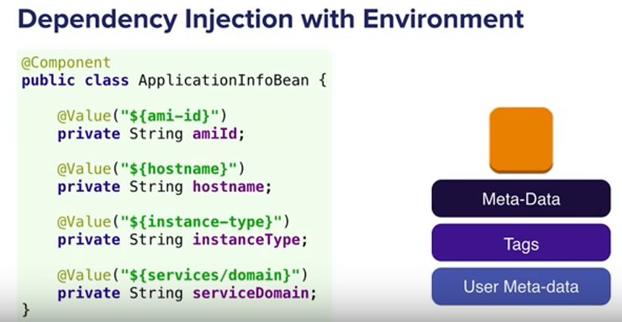

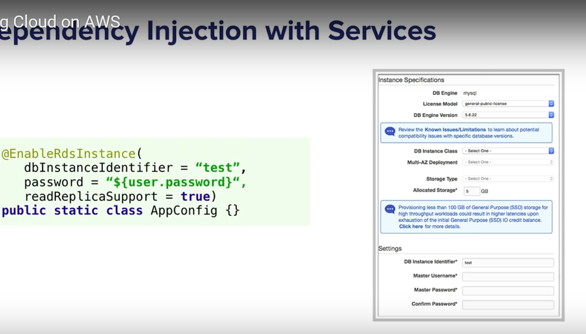

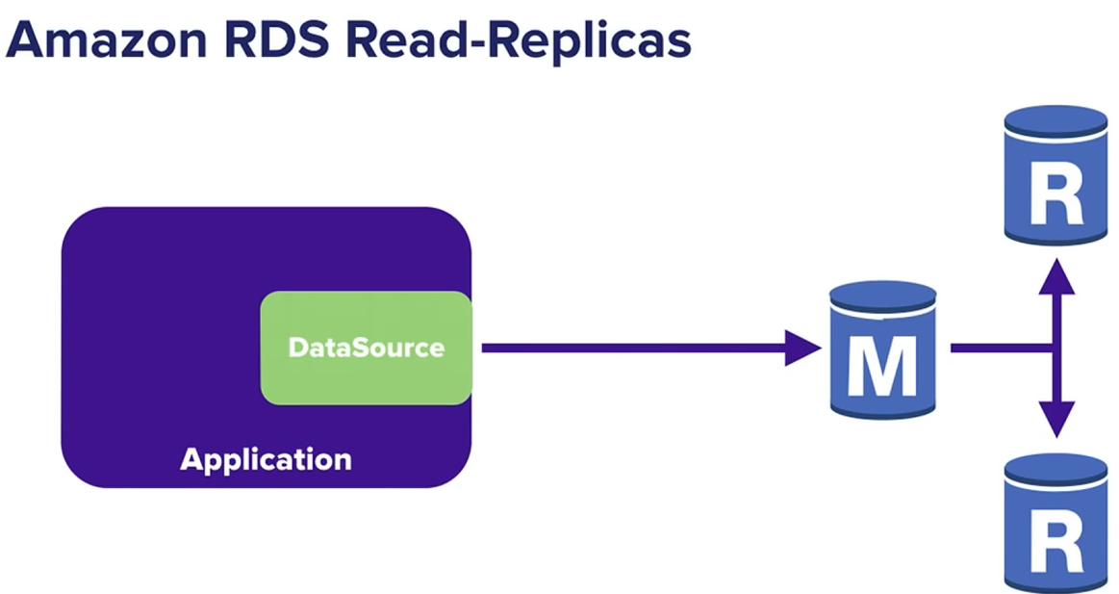

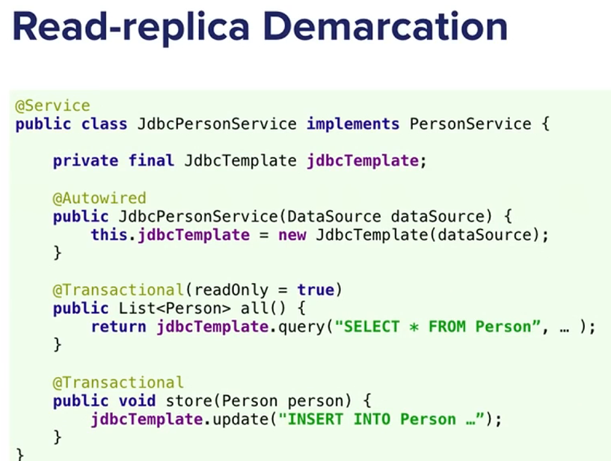

If read-only request does not go to master instance but weak replicas.

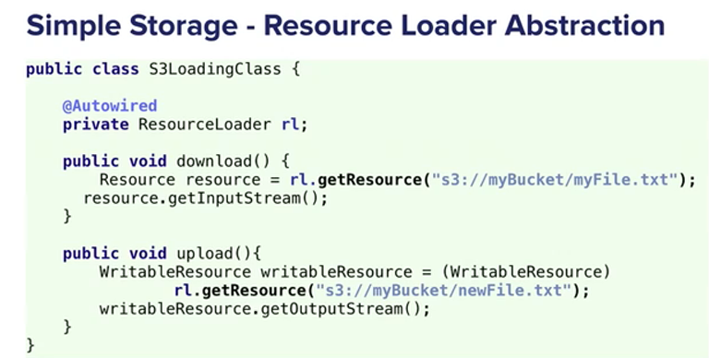

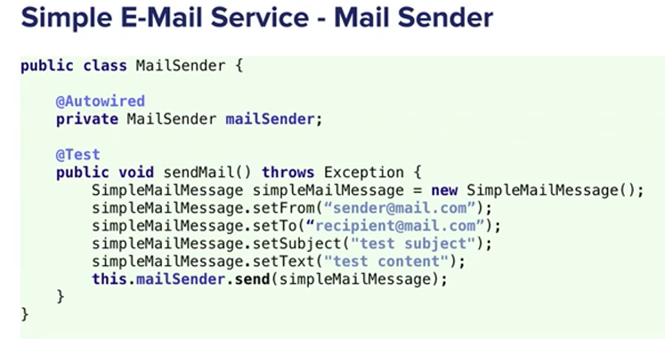

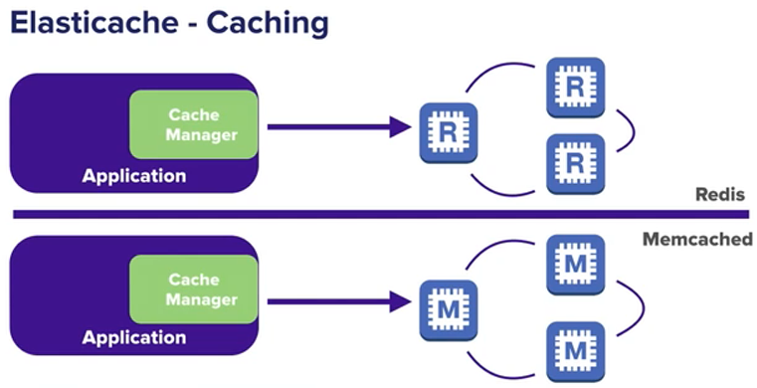

Redis used if lot of data to be cached

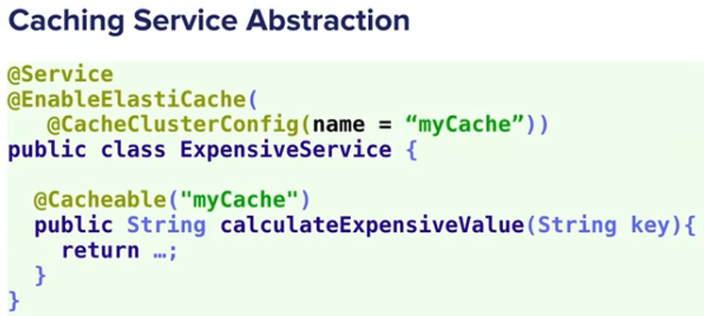

Get info if redis or memcached and set up the service

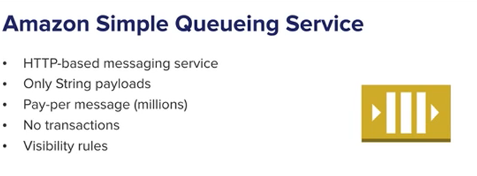

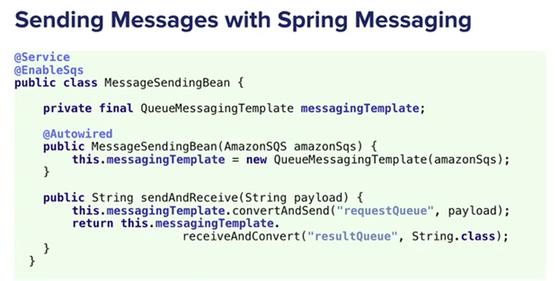

If synchronously have to receive many messages:

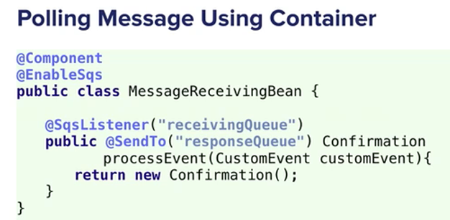

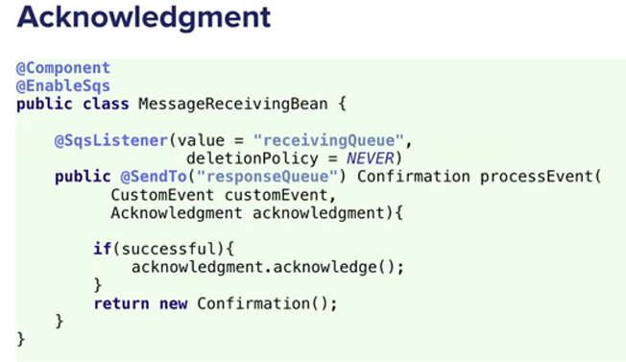

Bydeafult, messages deleted, but can be acknowledged

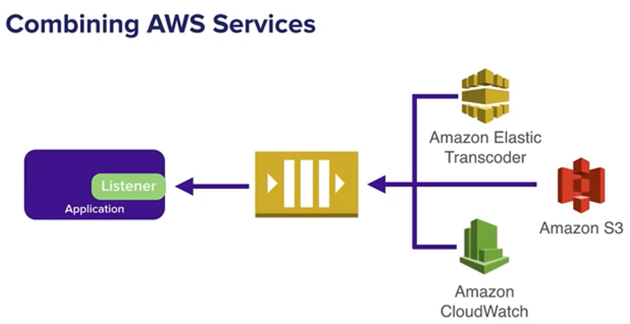

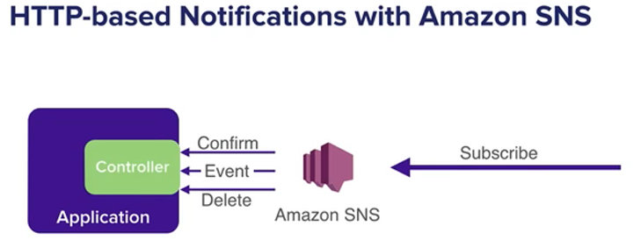

No polling, scalable

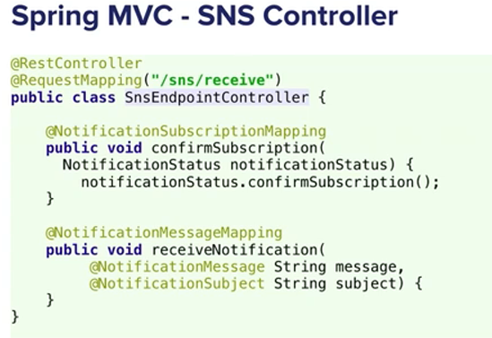

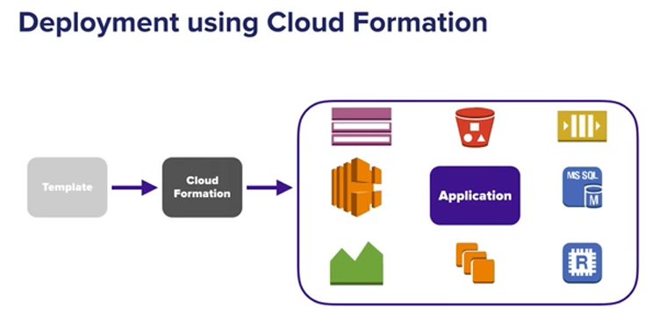

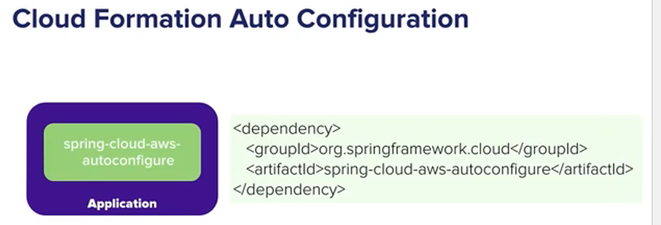

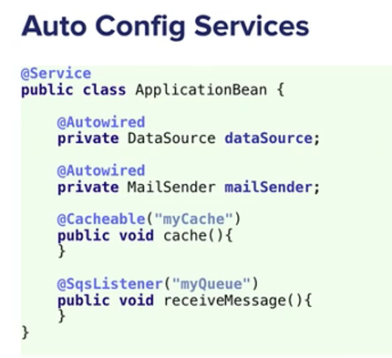

With the dependency, all services are injected that are available in stack

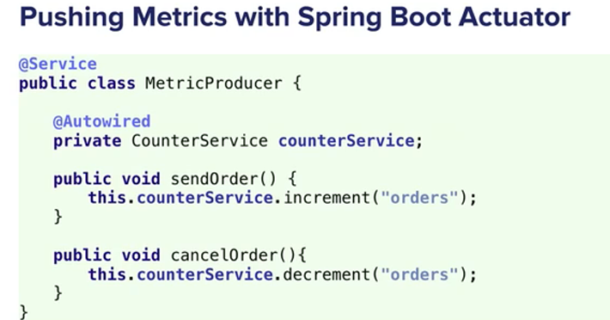

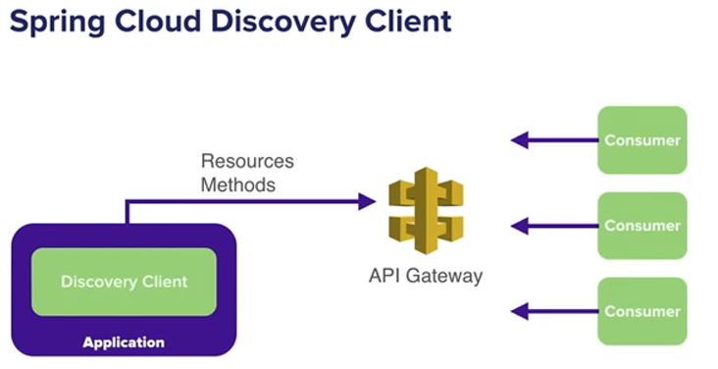

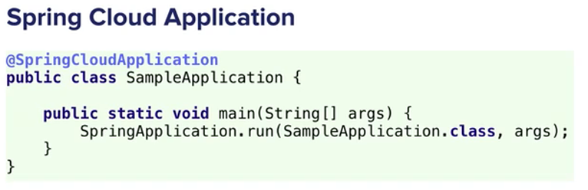

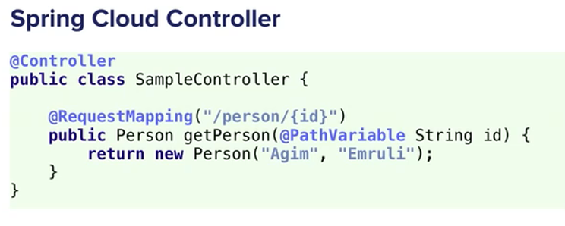

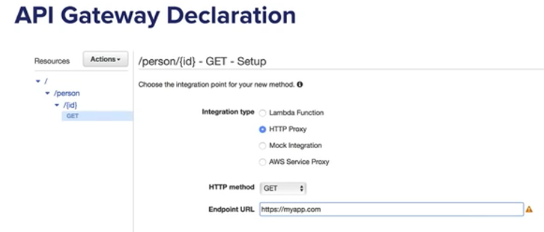

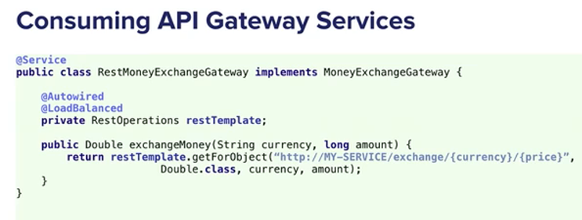

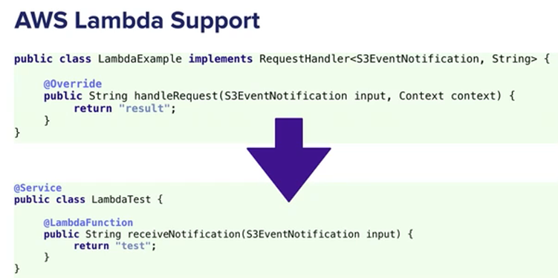

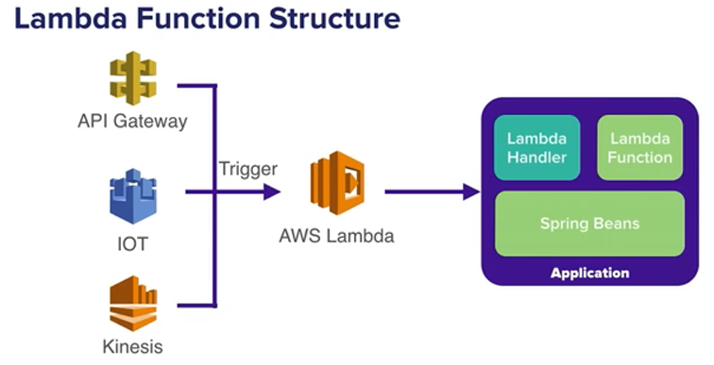

errorThreshold: after 20% of requests failing, will automatically open circuit

if service A down, B which depends on A down

So static data

To service B:

spring-cloud-starter-hystrix

@EnableHystrix or @EnableCircuitBreaker (spring cloud)

If not spring cloud, bean for hystrixcommandaspect and enable aspectj autoproxy

@HystrixCommand(groupkey: bydefault classname, commandKey: method name, fallback method.. which method to call when circuit is open, commandproperties, ignoreException: which exceptions i don't want fallback)

hystrics-javanica: annotations for hystrix

hystrix-metrics-event-stream: to see metrics of the applications, no of fallbacks, circuit open or close

https://github.com/Netflix/Hystrix/wiki

hystrix dashboard:

spring-cloud-starter-hystrix-dashboard

spring-boot-starter-actuator also needed

@EnableHystrixDashboard

Methid annotated with:

@GetMapping("/{username}")

@HystrixCommand(fallbackMethod="defaultQuotes", commandProperties= {

@HystrixProperty(name="circuitBreaker.sleepWindowInMilliseconds", value="60000"),

@HystrixProperty(name="circuitBreaker.errorThresholdPercentage", value="5")

})

create fallback method with same parameter

public List<Quote> defaultQuotes(String name){

//Can get data from backup db: old data.

List<Quote> quotes= new ArrayList<>();

return quotes;

}

Spring cloud on aws

Runnign app in cloud, needs to know hostname, instanceType, domain